**"AI-based Healthcare Diagnostics: Early Detection and Prediction”**

**Detailed Project Plan:**

The goal of using AI in healthcare for early prediction is to find diseases sooner and predict future health risks. AI can analyze medical data like patient records and test results to spot problems early, helping doctors treat patients before the illness gets worse. It also helps create personalized treatment plans and improves accuracy in diagnoses, leading to better health outcomes and lower healthcare costs.

**Detailed timeline with milestone:**

detailed timeline with milestones for the AI healthcare project focused on early prediction:

**Phase 1: Planning and Requirements (2 Weeks)**

- Milestone 1.1: Define Project Scope

- Deliverable: Project scope document

- Deadline: Week 1, Day 3

**- Milestone 1.2: Stakeholder Requirement Gathering**

- Deliverable: Requirement specification document

- Deadline: Week 1, Day 5

**- Milestone 1.3: Design System Architecture**

- Deliverable: Architecture diagram

- Deadline: Week 2, Day 5

**Phase 2: Infrastructure Setup and Data Collection (4 Weeks)**

- Milestone 2.1: Setup Vultr Instances

- Deliverable: Functional infrastructure

- Deadline: Week 3, Day 2

**- Milestone 2.2: Data Collection and Preprocessing**

- Deliverable: Cleaned dataset

- Deadline: Week 5, Day 5

**Phase 3: AI Model Development (6 Weeks)**

- Milestone 3.1:AI Model Building

- Deliverable: Initial AI models

- Deadline: Week 6, Day 5

**- Milestone 3.2: Train Models**

- Deliverable: Trained AI models

- Deadline: Week 8, Day 5

**- Milestone 3.3: Model Optimization**

- Deliverable: Optimized AI models

- Deadline: Week 9, Day 5

**- Milestone 3.4: Validate Models**

- Deliverable: Validation report

- Deadline: Week 10, Day 5

**Phase 4: System Integration and Deployment (3 Weeks)**

- Milestone 4.1: API Development

- Deliverable: API documentation

- Deadline: Week 11, Day 3

**- Milestone 4.2: Model Deployment on Vultr**

- Deliverable: Deployed models

- Deadline: Week 12, Day 5

**- Milestone 4.3: System Testing**

- Deliverable: Integration test report

- Deadline: Week 13, Day 5

**Phase 5: Performance Testing and Security Audits (2 Weeks)**

- Milestone 5.1: Load Testing

- Deliverable: Performance report

- Deadline: Week 14, Day 3

**- Milestone 5.2: Security Audit**

-Deliverable: Security audit report

- Deadline: Week 14, Day 5

**- Milestone 5.3: Documentation Finalization**

- Deliverable: Complete project documentation

- Deadline: Week 15, Day 5

**Phase 6: Final Presentation, Feedback, and Launch (2 Weeks)**

- Milestone 6.1: Prepare Final Presentation

- Deliverable: Presentation materials

- Deadline: Week 16, Day 3

**- Milestone 6.2: Stakeholder Feedback**

- Deliverable: Feedback report

- Deadline: Week 17, Day 2

**- Milestone 6.3: Official System Launch**

- Deliverable: Operational AI healthcare system

- Deadline: Week 17, Day 5

* **Milestone:**

|  |  |  |
| --- | --- | --- |
| phase | weeks | Milestone |
| Phase 1: Planning | 2 weeks | Scope, requirements, architecture |
| Phase 2: Infrastructure Setup | 4 weeks | Vultr setup, data collection |
| Phase 3: AI Model Development | 6 weeks | Model building, training, validation |
| Phase 4: Integration & Deployment | 3 weeks | API development, deployment, testing |
| Phase 5: Testing & Audit | 2 weeks | Performance testing, security audits |
| Phase 6: Final Launch | 2 weeks | Presentation, feedback, launch |

* **System Architecture:**

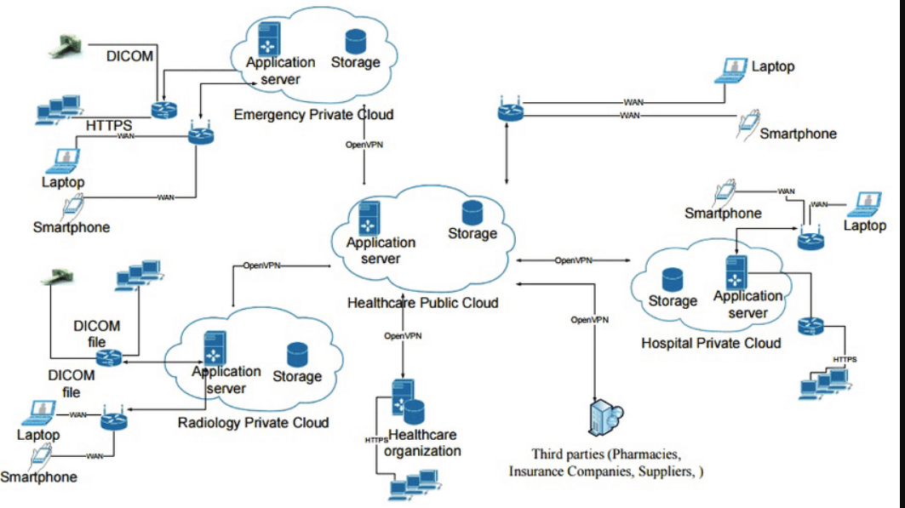

* **Component Diagram:**

